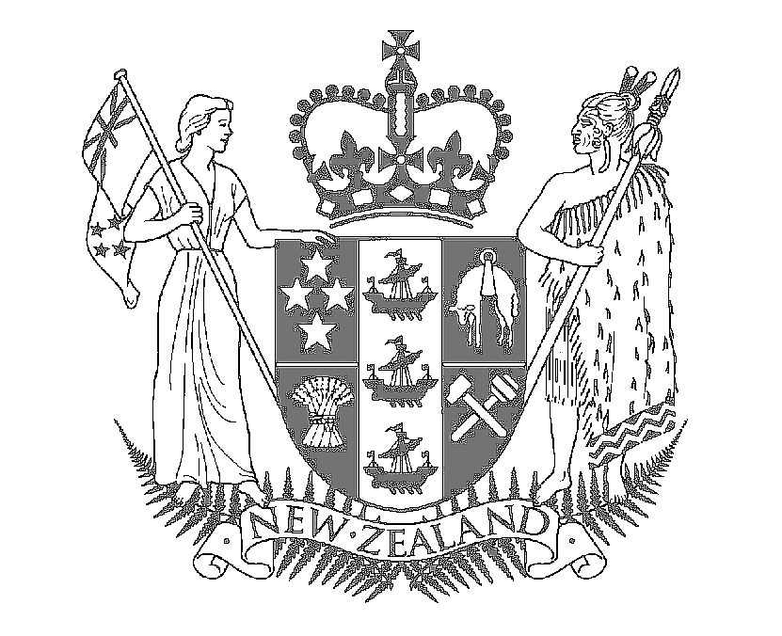

Speech Notes

HON MAHARA OKEROA
Associate Minister for Arts, Culture and Heritage

NGA TANGI O TE TANGATA – NGA REO O TE WHENUA

NELSON FRIDAY 23RD FEBRUARY SUTER ART GALLERY

Nga Tangi O Te Tangata – Nga Reo O Te Whenua No Te Tau Ihu O Te Waka A Maui

Songs of the People – Stories of the Land – From the Top of the South

Today we come together for the opening of this poignant exhibition which celebrates the songs and stories of Te Tau Ihu o te Waka a Maui.

I would like to acknowledge Ian McDonald, curator who had the vision for this exhibition, beginning as a Kaupapa Maori Arts millennium project to record the songs and stories of Te Tau Ihu. I would also like to recognize Golden Bay artist, Robin Slow, for his paintings which honour the whakapapa of Maori music and celebrate the revitalization of te reo Maori.

Thanks also to The Suter for hosting the exhibition and bringing the songs and stories to a broader audience.

Our thanks also to previous Director Helen Telford who believed and supported the project and has since left us for a new position as Assistant Director at the Govett Brewster Art Gallery in New Plymouth.

This exhibition is the result of many years work for Kaupapa Maori Arts, documenting waiata from all around Te Tau Ihu. Its purpose is to represent the unique diversity of the region while binding mana whenua in this area.

Therefore, Nga Tangi o te Tangata – Nga Reo o Te Whenua weaves together the diverse traditions of those who share kaitiakitanga over this land while providing an invaluable resource for future generations.

The CD that has been produced, records songs that tell the stories of this region. Most importantly, the CD documents the work of the regions culture and language revitalization strategies - such as waiata by Maori immersion classes from Parklands Primary School in Motueka and the Motueka High School and waiata composed Nga Manu Tui, the whanau of Onetahua marae.

Another example is from the Hippolite whanau who had lost their ancient waiata and through research they found the words but not the melody. So they recomposed the music and put that to the words of their waiata. These are now recorded and will not be lost to further generations.

Onetahua Marae where they compose and then sing their waiata for the different occasions they have on their Marae. They tell their stories and express their identity in their waiata. It brings them together. Through the songs this will revitalize the language and the culture once again.

Between each song that is recorded on the CD, there is a musical interlude played by Richard Nunns who has made a valuable contribution to the retention and promotion of Maori musical instruments. And we are proud to have such people as Richard living among us in Te Tau Ihu.

Kaupapa Maori Arts say this is what they wanted to capture and this has been done through the CD which has been produced.

This exhibition captures and recognizes mana whenua and therefore all Iwi groups, there is no exclusion but captures all. So the Suter becomes a marae where all of the iwi can share their culture in their own stories and songs.

I would also like to especially acknowledge Robin Slow, artist from Golden Bay who has very much complemented the kaupapa of this project.

Robyn became so inspired by this project through his involvement with Onetahua Marae that he created a series of paintings that are exhibited here today. The paintings honour those ancestors associated with Maori music, lament the loss of language during the period of colonization and celebrates the revitalization of culture, language and mana through participation in the arts.

In the catalogue, Curator Ian McDonald and Taitamariki Mihaere have written interpretations for the paintings in both Maori and English and here are some of their beautiful words that they use to describe the paintings

Mai te niho Tohora te reo o Tangaroa – The voice of Tangaroa is heard in the tooth of the whale
Mai te whakaoranga o te mahi toi ka tuhonohono te ao Pakeha me to ao Maori

Through the restoration of the arts different cultures are brought together.

Before the opening of this exhibition the paintings and CD have traveled back to the groups who participated in the project. By doing so, their gift is symbolically returned and now past on to a wider audience.

Therefore Nga Tangi O Te Tangata Nga Reo O Te Whenua weaves together the diverse traditions of those who share kaitiakitanga (guardianship) over this land while providing an invaluable resource for future generations.

